### **Write the python program for Map Coloring to implement CSP.**

### **AIM**

To implement the **Map Coloring Problem** using **Constraint Satisfaction Problem (CSP)** approach in Python, ensuring no two adjacent regions share the same color.

### **ALGORITHM**

1. Represent the regions as a **graph** where nodes are states and edges denote adjacency.
2. Define a set of available colors.
3. Assign colors to each region one by one using **backtracking**:
   1. Check if the chosen color does not conflict with neighbors.
   2. If safe, assign the color and move to the next region.
   3. If conflict arises, backtrack and try another color.
4. Repeat until all regions are assigned a valid color.
5. Output the final assignment as the solution.

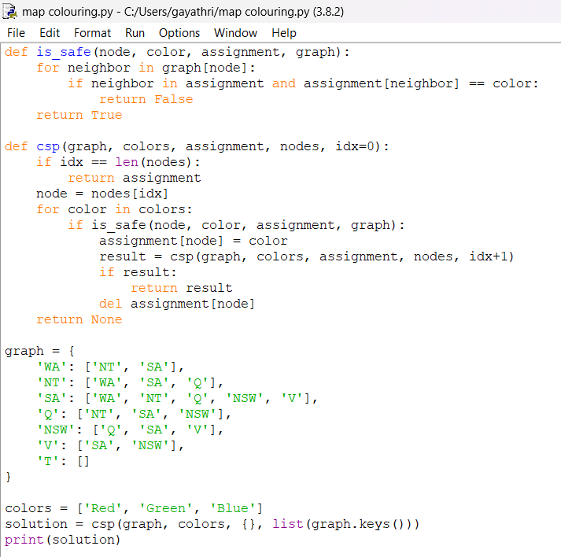

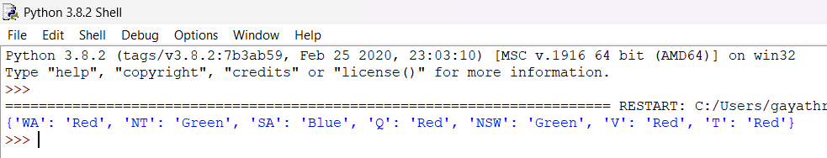

### **RESULT**

For the given Australian map graph with 3 colors (Red, Green, Blue), the program outputs a valid coloring: